LOAD TESTING RESULT:

Resident Set Size : Maximum number of kilobytes of physical memory that processes used simultaneously.

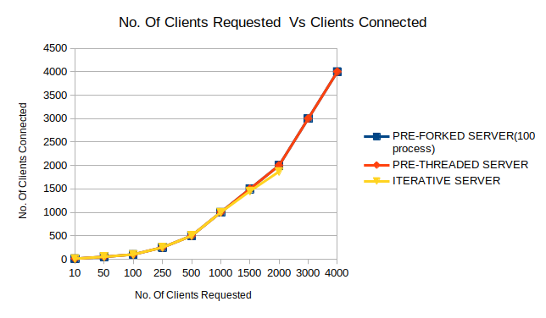
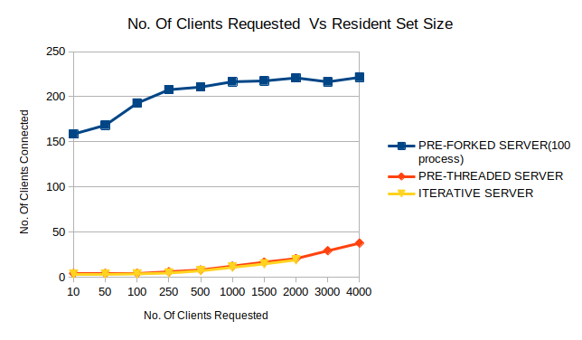
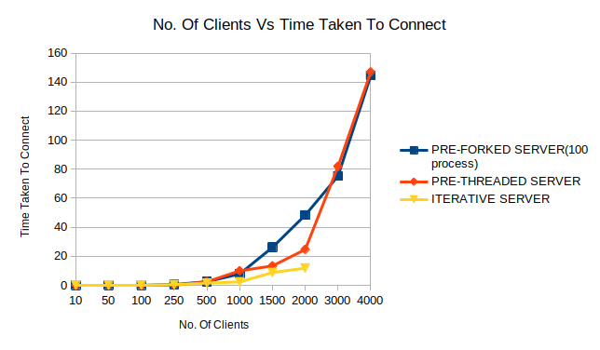
ITERATIVE SERVER :
NO OF CLIENTS REQUESTING SERVICE | ITERATIVE SERVER
NO OF CLIENTS REQUESTING SERVICE | RESIDENT SET SIZE(in mb) | NO. OF CLIENTS CONNECTED | TOTAL TIME TAKEN TO CONNECT TO SERVER.(in seconds)
10 | 3.328 | 10 | .005236
50 | 3.328 | 50 | .021471
100 | 3.456 | 100 | 0.05412
250 | 4.480 | 250 | 0.45623
500 | 6.912 | 500 | 1.46895
1000 | 10.752 | 1000 | 2.32106
1500 | 14.592 | 1451 | 8.74753
2000 | 18.944 | 1869 | 11.7981
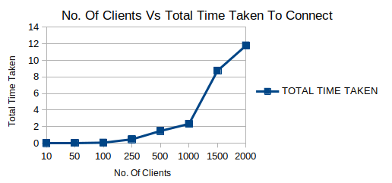

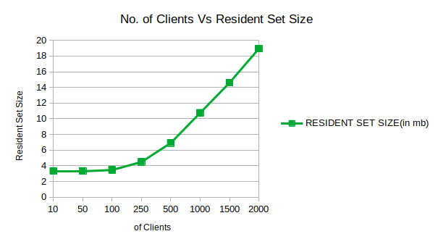

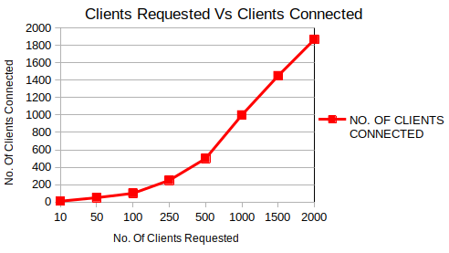
PRE-THREADED SERVER ( 100 THREADS) :
NO OF CLIENTS REQUESTING SERVICE | PRE-THREADED SERVER(100 THREADS)
NO OF CLIENTS REQUESTING SERVICE | RESIDENT SET SIZE(in mb) | NO. OF CLIENTS CONNECTED | TOTAL TIME TAKEN TO CONNECT TO SERVER.(in seconds)
10 | 3.968 | 10 | 0.00583
50 | 4.096 | 50 | 0.02230
100 | 4.224 | 100 | 0.03079
250 | 5.888 | 250 | 0.13688
500 | 7.936 | 500 | 2.45246
1000 | 12.160 | 1000 | 9.93264
1500 | 16.512 | 1500 | 13.32865
2000 | 20.480 | 2000 | 24.64993
3000 | 29.184 | 3000 | 81.93203
4000 | 37.632 | 4000 | 146.9984

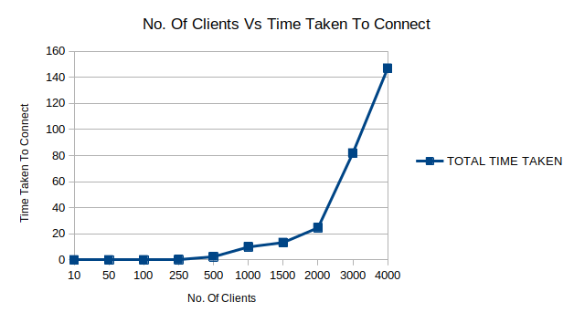

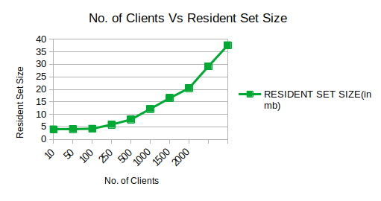
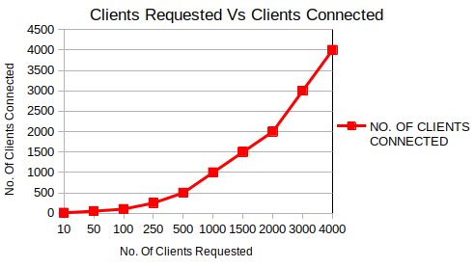

PRE-FORKED SERVER ( 100 PROCESS ) :
NO OF CLIENTS REQUESTING SERVICE | PRE-FORKED SERVER(100 process)
NO OF CLIENTS REQUESTING SERVICE | RESIDENT SET SIZE(in mb) | NO. OF CLIENTS CONNECTED | TOTAL TIME TAKEN TO CONNECT TO SERVER.(in seconds)
10 | 158.596 | 10 | 0.00469
50 | 168.448 | 50 | 0.02087
100 | 192.896 | 100 | 0.07835
250 | 207.748 | 250 | 0.54144
500 | 210.692 | 500 | 2.41747
1000 | 216.576 | 1000 | 7.83464
1500 | 217.472 | 1500 | 26.14476
2000 | 220.816 | 2000 | 48.31828
3000 | 216.456 | 3000 | 75.26824
4000 | 221.440 | 4000 | 144.47596

